**FreeFall : Game Design Document (GDD)**

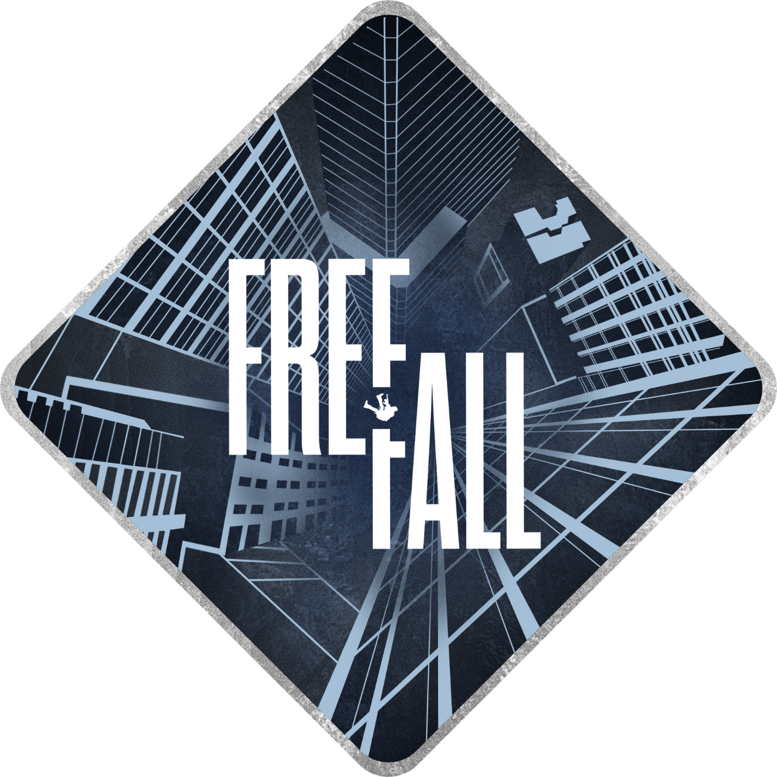

***‘There are only a few very important life changing and character building moments in life - seize them’*** - Vivek Kumar (Messi)

|  |  |  |
| --- | --- | --- |
| Table of Contents  [1 Game Overview](https://n-xovwktmtjsnaxyc2mwes2xu7pohqedmdm6zjw5q-2lu-script.googleusercontent.com/userCodeAppPanel)  [2 High Concept](https://n-xovwktmtjsnaxyc2mwes2xu7pohqedmdm6zjw5q-2lu-script.googleusercontent.com/userCodeAppPanel)  [3 Unique Selling Points](https://n-xovwktmtjsnaxyc2mwes2xu7pohqedmdm6zjw5q-2lu-script.googleusercontent.com/userCodeAppPanel)  [4 Platform Minimum Requirements](https://n-xovwktmtjsnaxyc2mwes2xu7pohqedmdm6zjw5q-2lu-script.googleusercontent.com/userCodeAppPanel)  [5 Competitors / Similar Titles](https://n-xovwktmtjsnaxyc2mwes2xu7pohqedmdm6zjw5q-2lu-script.googleusercontent.com/userCodeAppPanel)  [6 Synopsis](https://n-xovwktmtjsnaxyc2mwes2xu7pohqedmdm6zjw5q-2lu-script.googleusercontent.com/userCodeAppPanel)  [7 Game Objectives](https://n-xovwktmtjsnaxyc2mwes2xu7pohqedmdm6zjw5q-2lu-script.googleusercontent.com/userCodeAppPanel)  [8 Game Rules](https://n-xovwktmtjsnaxyc2mwes2xu7pohqedmdm6zjw5q-2lu-script.googleusercontent.com/userCodeAppPanel)  [9 Game Structure](https://n-xovwktmtjsnaxyc2mwes2xu7pohqedmdm6zjw5q-2lu-script.googleusercontent.com/userCodeAppPanel)  [10 Game Play](https://n-xovwktmtjsnaxyc2mwes2xu7pohqedmdm6zjw5q-2lu-script.googleusercontent.com/userCodeAppPanel)  [10.1 Game Controls](https://n-xovwktmtjsnaxyc2mwes2xu7pohqedmdm6zjw5q-2lu-script.googleusercontent.com/userCodeAppPanel)  [10.2 Game Camera](https://n-xovwktmtjsnaxyc2mwes2xu7pohqedmdm6zjw5q-2lu-script.googleusercontent.com/userCodeAppPanel)  [10.2.1 HUD](https://n-xovwktmtjsnaxyc2mwes2xu7pohqedmdm6zjw5q-2lu-script.googleusercontent.com/userCodeAppPanel)  [10.2.2 Maps](https://n-xovwktmtjsnaxyc2mwes2xu7pohqedmdm6zjw5q-2lu-script.googleusercontent.com/userCodeAppPanel)  [11 Players](https://n-xovwktmtjsnaxyc2mwes2xu7pohqedmdm6zjw5q-2lu-script.googleusercontent.com/userCodeAppPanel)  [11.1 Characters](https://n-xovwktmtjsnaxyc2mwes2xu7pohqedmdm6zjw5q-2lu-script.googleusercontent.com/userCodeAppPanel)  [11.2 Metrics](https://n-xovwktmtjsnaxyc2mwes2xu7pohqedmdm6zjw5q-2lu-script.googleusercontent.com/userCodeAppPanel)  [11.3 States](https://n-xovwktmtjsnaxyc2mwes2xu7pohqedmdm6zjw5q-2lu-script.googleusercontent.com/userCodeAppPanel)  [11.4 Weapons](https://n-xovwktmtjsnaxyc2mwes2xu7pohqedmdm6zjw5q-2lu-script.googleusercontent.com/userCodeAppPanel)  [12 Player Line-up](https://n-xovwktmtjsnaxyc2mwes2xu7pohqedmdm6zjw5q-2lu-script.googleusercontent.com/userCodeAppPanel)  [13 NPC](https://n-xovwktmtjsnaxyc2mwes2xu7pohqedmdm6zjw5q-2lu-script.googleusercontent.com/userCodeAppPanel)  [13.1 Enemies](https://n-xovwktmtjsnaxyc2mwes2xu7pohqedmdm6zjw5q-2lu-script.googleusercontent.com/userCodeAppPanel)  [13.1.1 Enemy States](https://n-xovwktmtjsnaxyc2mwes2xu7pohqedmdm6zjw5q-2lu-script.googleusercontent.com/userCodeAppPanel)  [13.1.2 Enemy Spawn Points](https://n-xovwktmtjsnaxyc2mwes2xu7pohqedmdm6zjw5q-2lu-script.googleusercontent.com/userCodeAppPanel)  [13.2 Allies / Companions](https://n-xovwktmtjsnaxyc2mwes2xu7pohqedmdm6zjw5q-2lu-script.googleusercontent.com/userCodeAppPanel)  [13.2.1 Ally States](https://n-xovwktmtjsnaxyc2mwes2xu7pohqedmdm6zjw5q-2lu-script.googleusercontent.com/userCodeAppPanel)  [13.2.2 Ally Spawn Points](https://n-xovwktmtjsnaxyc2mwes2xu7pohqedmdm6zjw5q-2lu-script.googleusercontent.com/userCodeAppPanel)  [14 Art](https://n-xovwktmtjsnaxyc2mwes2xu7pohqedmdm6zjw5q-2lu-script.googleusercontent.com/userCodeAppPanel)  [14.1 Setting](https://n-xovwktmtjsnaxyc2mwes2xu7pohqedmdm6zjw5q-2lu-script.googleusercontent.com/userCodeAppPanel)  [14.2 Level Design](https://n-xovwktmtjsnaxyc2mwes2xu7pohqedmdm6zjw5q-2lu-script.googleusercontent.com/userCodeAppPanel)  [14.3 Audio](https://n-xovwktmtjsnaxyc2mwes2xu7pohqedmdm6zjw5q-2lu-script.googleusercontent.com/userCodeAppPanel)  [15 Procedurally Generated Content](https://n-xovwktmtjsnaxyc2mwes2xu7pohqedmdm6zjw5q-2lu-script.googleusercontent.com/userCodeAppPanel)  [15.1 Environment](https://n-xovwktmtjsnaxyc2mwes2xu7pohqedmdm6zjw5q-2lu-script.googleusercontent.com/userCodeAppPanel)  [15.2 Levels](https://n-xovwktmtjsnaxyc2mwes2xu7pohqedmdm6zjw5q-2lu-script.googleusercontent.com/userCodeAppPanel)  [15.3 Artificial Intelligence NPC](https://n-xovwktmtjsnaxyc2mwes2xu7pohqedmdm6zjw5q-2lu-script.googleusercontent.com/userCodeAppPanel)  [15.4 Visual Arts](https://n-xovwktmtjsnaxyc2mwes2xu7pohqedmdm6zjw5q-2lu-script.googleusercontent.com/userCodeAppPanel)  [15.5 Audio](https://n-xovwktmtjsnaxyc2mwes2xu7pohqedmdm6zjw5q-2lu-script.googleusercontent.com/userCodeAppPanel)  [15.6 Minimum Viable Product (MPV)](https://n-xovwktmtjsnaxyc2mwes2xu7pohqedmdm6zjw5q-2lu-script.googleusercontent.com/userCodeAppPanel)  [16 Wish List](https://n-xovwktmtjsnaxyc2mwes2xu7pohqedmdm6zjw5q-2lu-script.googleusercontent.com/userCodeAppPanel)   |  | | --- | |  | | Game Development Team Members    PRODUCER  Vivek Kumar (Messi)    PRODUCTION MANAGER  Vivek Kumar (Messi)    PRODUCTION COORDINATOR  Vivek Kumar (Messi)  GAME DESIGNERS  Vivek Kumar (Messi)  SYSTEMS/IT COORDINATOR  Vivek Kumar (Messi)  PROGRAMMERS  Vivek Kumar (Messi)  TECHNICAL ARTISTS  Vivek Kumar (Messi)  AUDIO ENGINEERS  Vivek Kumar (Messi)  UX TESTERS  Vivek Kumar (Messi) |

|  |
| --- |
|  |

# 1 Game Overview

Title: FreeFall

Platform: PC Standalone

Genre: Bottom Scroller

Rating: (10+) ESRB

Target: Casual gamer (aging from 10 - 50)

Release date: November, 2019

Publisher: Tree of Life

Description: FreeFall is a bottom scroller 2D game where the player is a fox whose mother is very ill. Player goes to the wise elder who says that a special grass is needed at the bottom of the well of life to save the mother. Players needs to traverse the dangerous well and reach the bottom of the well to secure the grass to save his mother. There are various poisonous substances inside the wells and look purple in color. Player should avoid contact with such objects and touching them respawns the player back to the starting point. For the sake of realism and difficulty the player only has one life hence delicate precision controls are required.

# 2 High Concept

FreeFall sets the player on top of a special water well where he has the objective to navigate to the bottom of well to secure the objective. The player needs to dodge poisonous substances inside the well. Contact with such objects respawns the player back to the starting point. Player can control their movement in the air. Use jump mechanics carefully to navigate past difficult obstacles.

# 3 Unique Selling Points

* Unique Story
* Easy to play but hard to win.
* Classic retro Gaming feel.

# 4 Platform Minimum Requirements

Processor: Intel core i3 3200 or equivalent.

Ram: 4 GB DDR3

Graphics: Onboard Graphics with Pixel Shader 4 or above.

Resolution: 1280 X 720 (Recommended: 1920 X 1080)

# 5 Competitors / Similar Titles

* Mario
* Donkey Kong
* Duke Nukem

# 6 Synopsis

Once upon a time there was a happy fox called loonie who lived with his mother moonie in the beautiful mountains of the shire.

Moonie one day suddenly fell ill. The doctors said it was due to the curse of the ring. Loonie loved his mother very much and wanted to save her. When the doctors failed to help moonie, Loonie went to Gandalf the Gray, a wise sorcerer. Gandalf told loonie that in order to save his mother he would need to get the grass of life which grows only inside the well of life at the far bottom where only the truly courageous can go.

The well of life used to be pure but damn the ring contaminated it too. Now our brave fox looney has to traverse the scary well to save his mother.

# 7 Game Objectives

The Objective of the Game is to get to the bottom of the well of life and find the grass of life while avoiding poisonous objects along the way.

# 8 Game Rules

The game level is a closed environment set in a underground well. Player must not make contact with purple rocks and hanging objects which are poisonous. Player will respawn to the starting point if he dies.

# 9 Game Structure

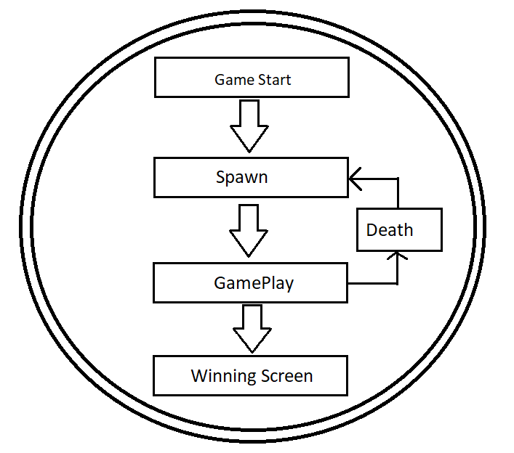

# 10 Game Play

## 10.1 Game Controls

Left arrow key: move left

Right arrow key: move right

Space: Jump

Hint : Movement Enabled in air.

## 10.2 Game Camera

When the game starts the camera is fixed for the UI and doesn’t move at all during the menu and loading screens.

When the level starts, the camera will focus on the player and moves with the player only on the Y-Axis (the vertical direction).

### 10.2.1 HUD

No HUD was implemented to give a realistic non-game like immersion experience to the user.

### 10.2.2 Maps

Linear vertical map. Player has to keep going down until they reach the bottom.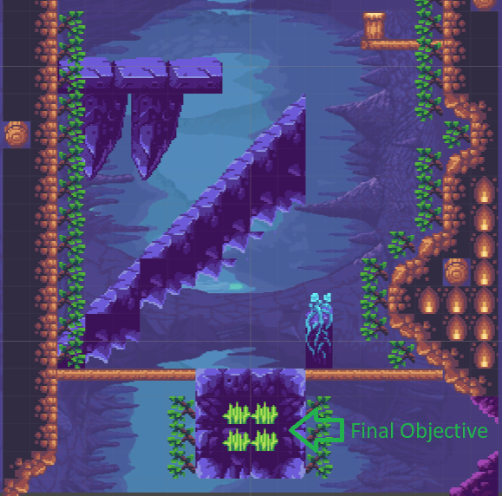

# 11 Players

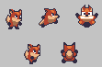The main character our protagonist is a fox called looney.

Looking is a charming cute fox who loves his mother very much. He played soccer while growing up, that’s why he is very swift. He can use his tail to control himself in the air.

Player Metrics

Horizontal Speed: 6

Vertical Jump Force: 725

Max Health: 1

Attack Damage: N/A

Time to attack: N/A

## 11.1 Characters

1. Looney : Fox (Main Character)

2. Mooney : Looney’s mother (Tigress).

3. Gandalf The Gray : Wise Sage with a sense of humor.

## 11.2 Player Metrics

Horizontal Speed: 6

Vertical Jump Force: 725

Max Health: 1

Attack Damage: N/A

Time to attack: N/A

## 11.3 Player States

Idle: The idle state is cycled animation where the Player is just standing still while moving a little. It plays back when the Player remains still.

Move: The movement animation will cause the character to perform a running animation. It will be triggered when the Player moves the character.

Jump/Fall: The flying animation will appear whenever user is falling at a velocity or jumping.

## 11.4 Weapons

FreeFall is more of a peaceful relaxing game and our main character is an underdog. Hence, no weapons.

# 12 Player Line-up



The Beloved Looney.

# 13 NPC

1. Mooney : Looney’s mother (Tigress).

2. Gandalf The Gray : Wise Sage with a sense of humor.

## 13.1 Enemies

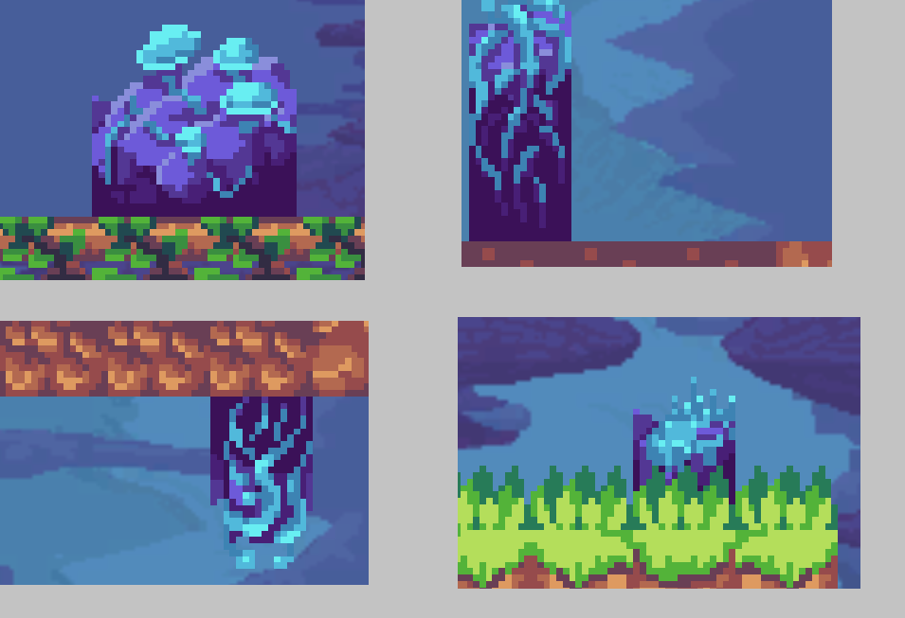

### 13.1.1 Enemy States

Enemies are in a dormant boring state.

### 13.1.2 Enemy Spawn Points

Strategically placed along crucial choke points creating a sense of imprisonment before the trap and a sense of freedom after escape.

## 13.2 Allies / Companions

Gandalf the Gray (NPC).

# 14 Art

## 14.1 Setting

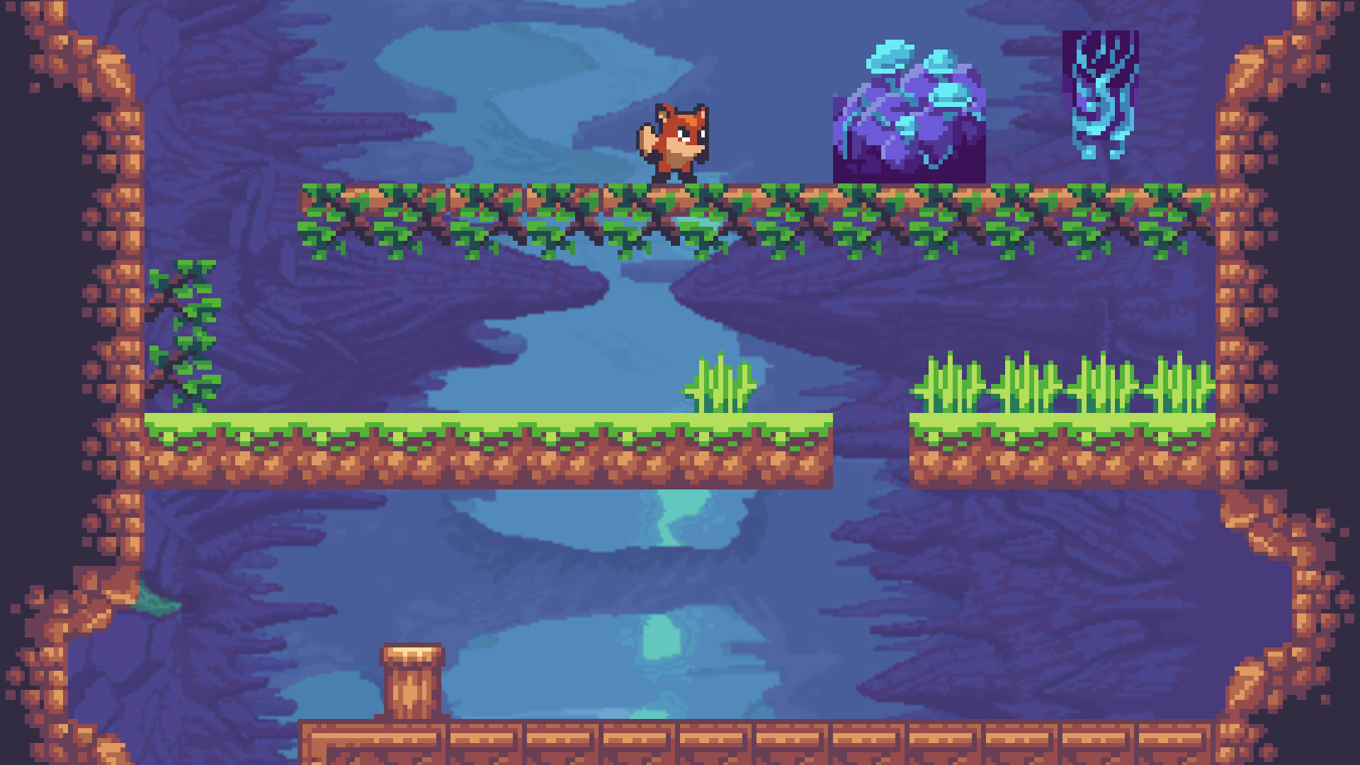

The game takes place in a mystical well called the “The well of life”. It has been corrupted by the dark forces but there are still signs of life inside it. 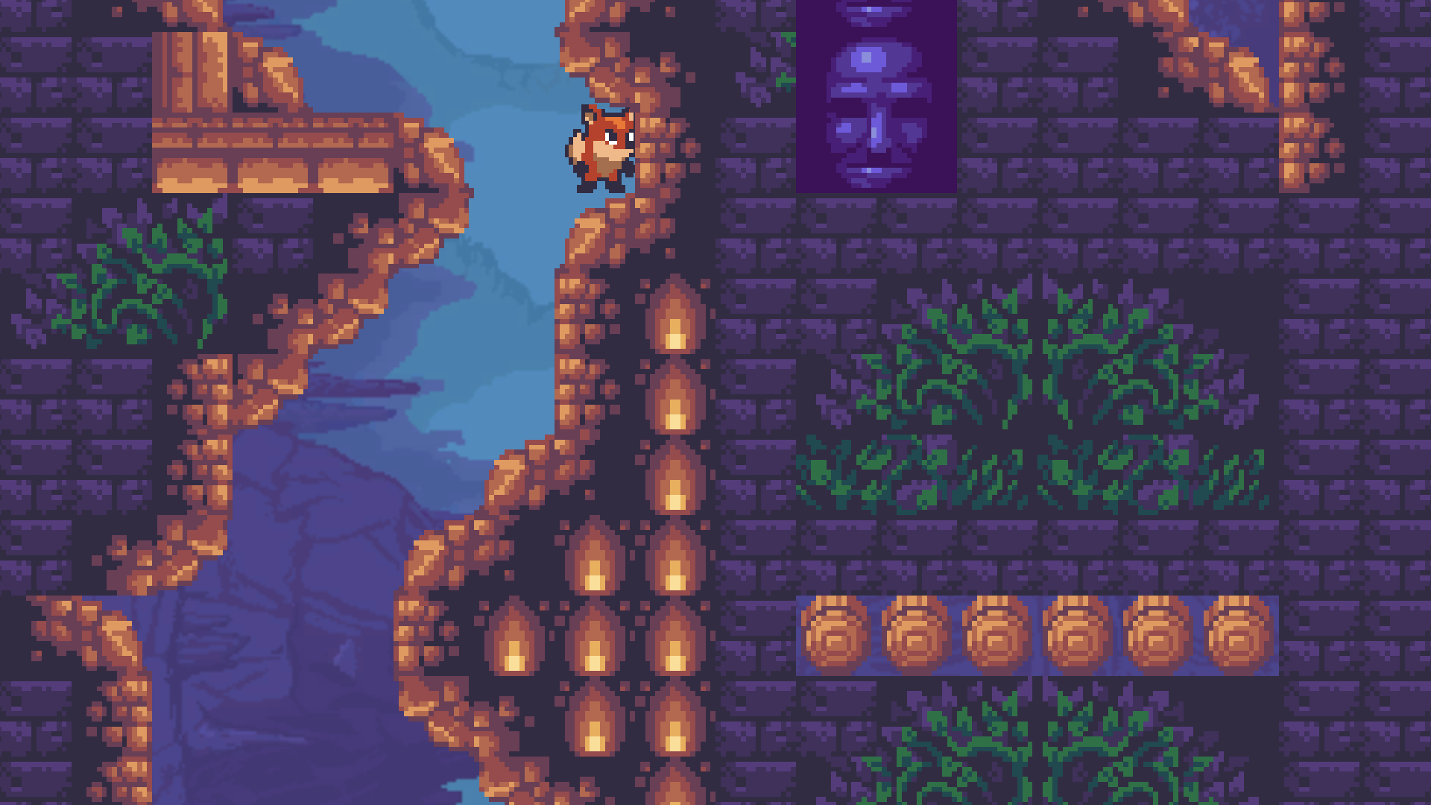

The outer walls are uneven and irregular signifying damage dealt to it. A collection of trees and other fauna can be found in various places. There are also decaying dead flora that can be seen in various places as well as spooky faces inside walls. Also, various anchor points, bridges, fire lantern, etc. can be found.

## 14.2 Level Design

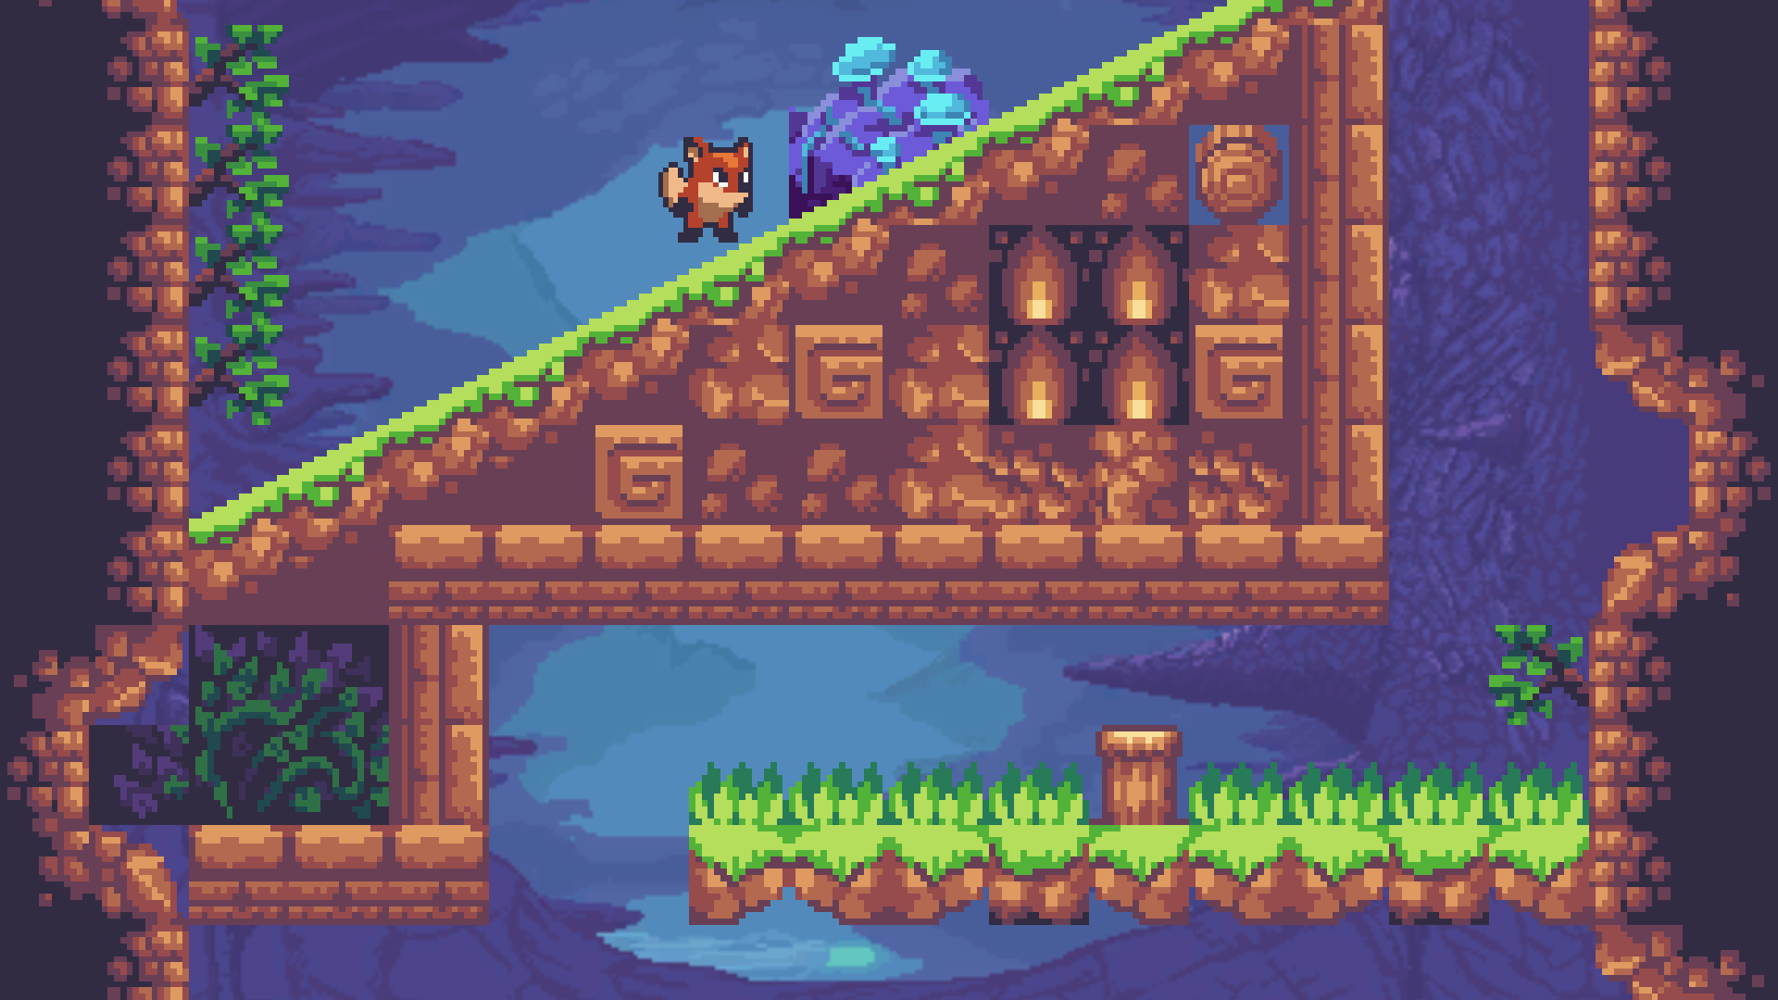

Slopes along with a damage obstacle requires a very calculated uphill jump.

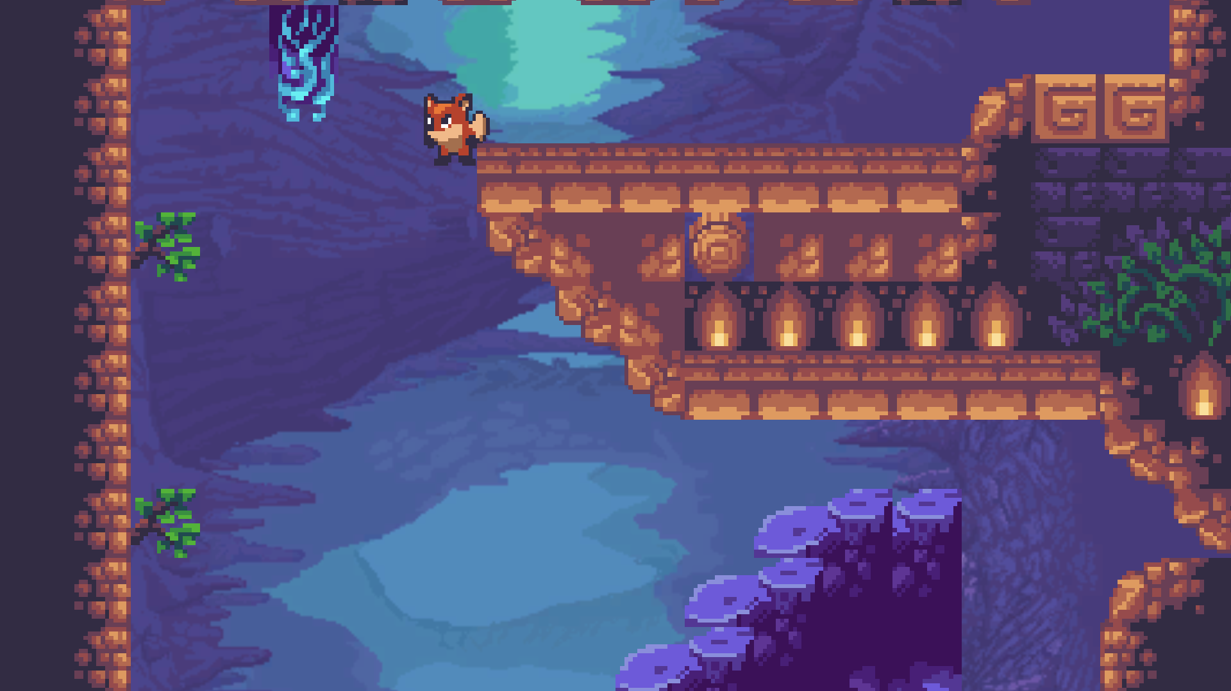

Cannot make jump here because of hanging obstacles.

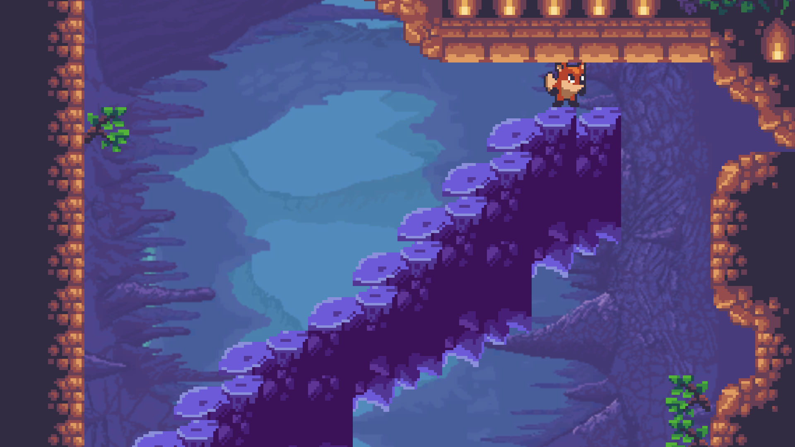

Very little downward visibility requires a slow careful approach to not land in a trap.

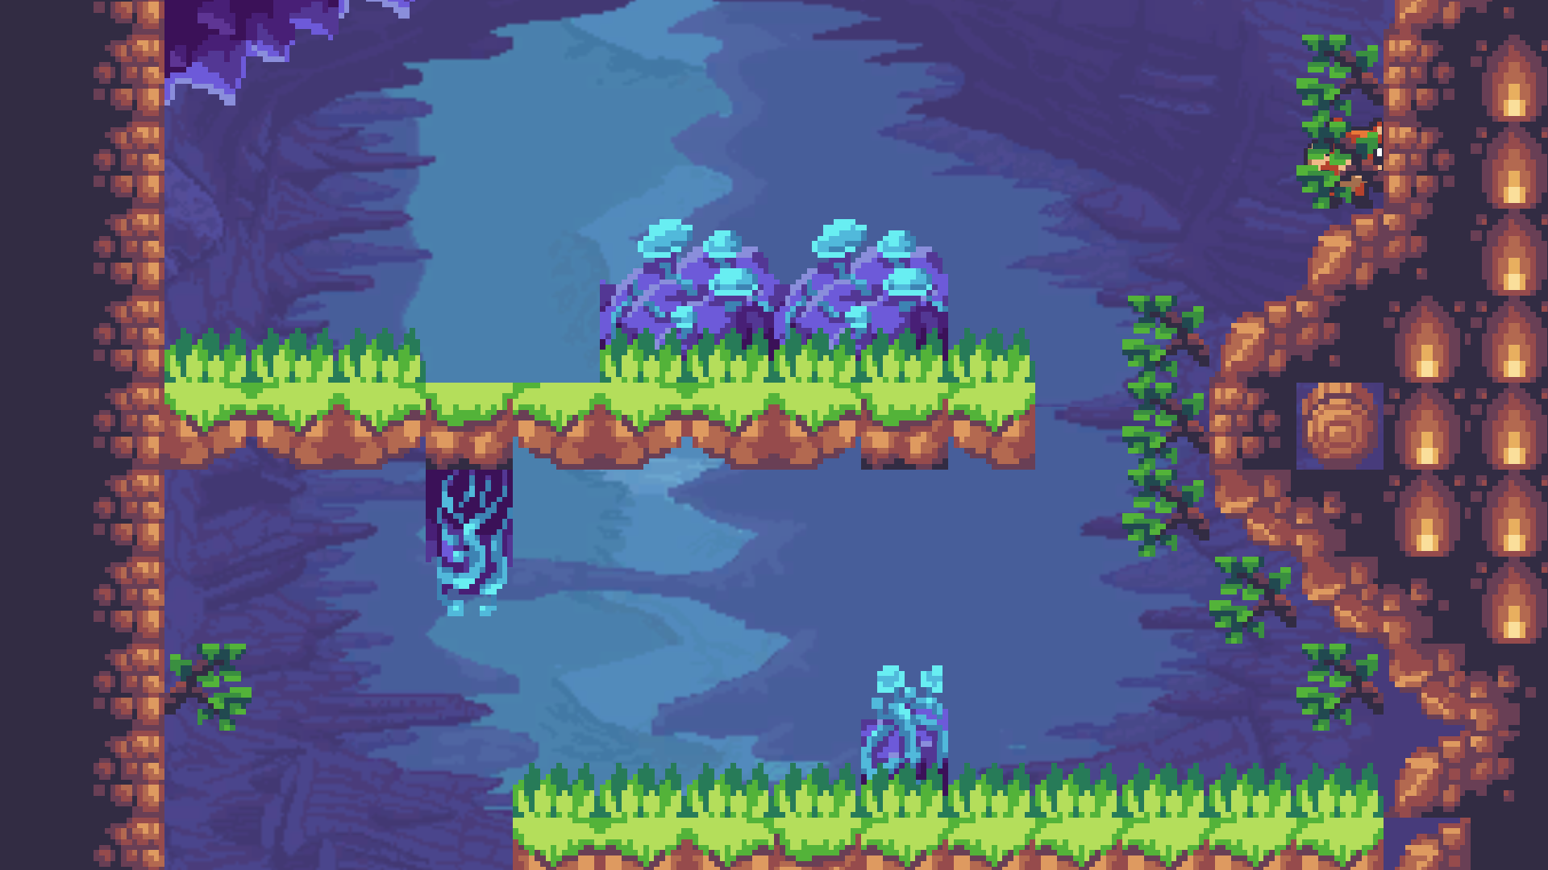

Both hanging and floor obstacle requires delicate jump controls and in-air suppression of jump.

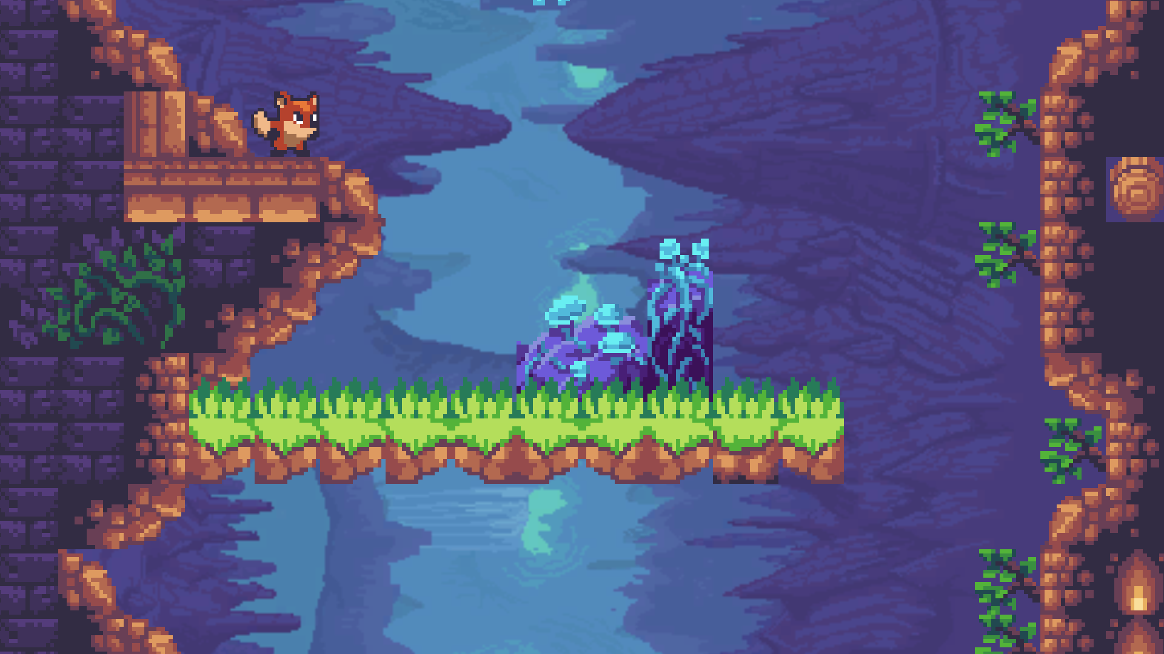

Decision requirement to jump all the way risking reset or to play it safe and jump down in a safe position first.

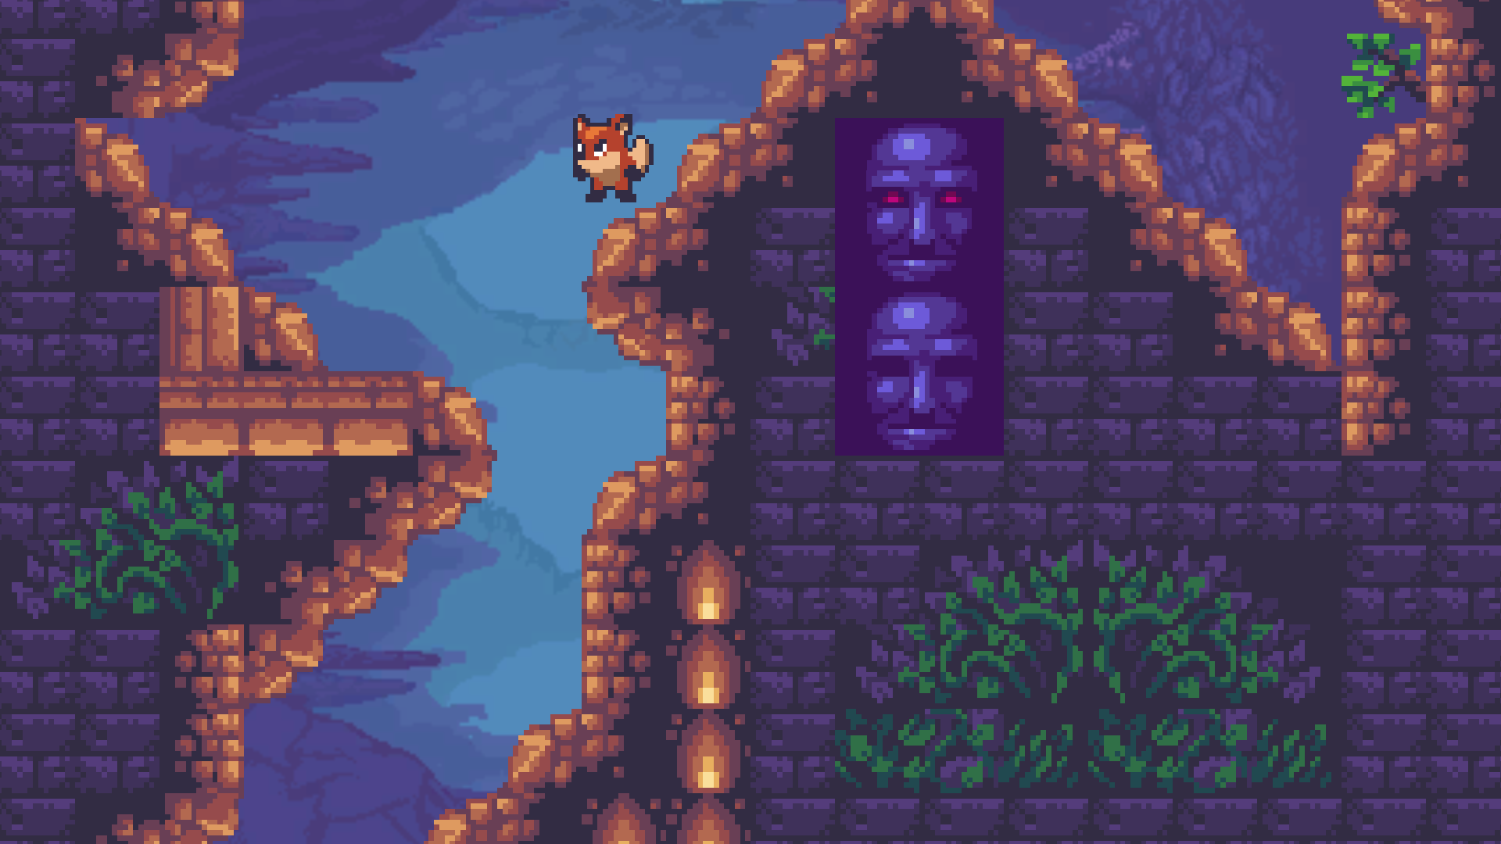

Only one narrow path down to create the feeling of getting trapped and a big obstacle approaching.

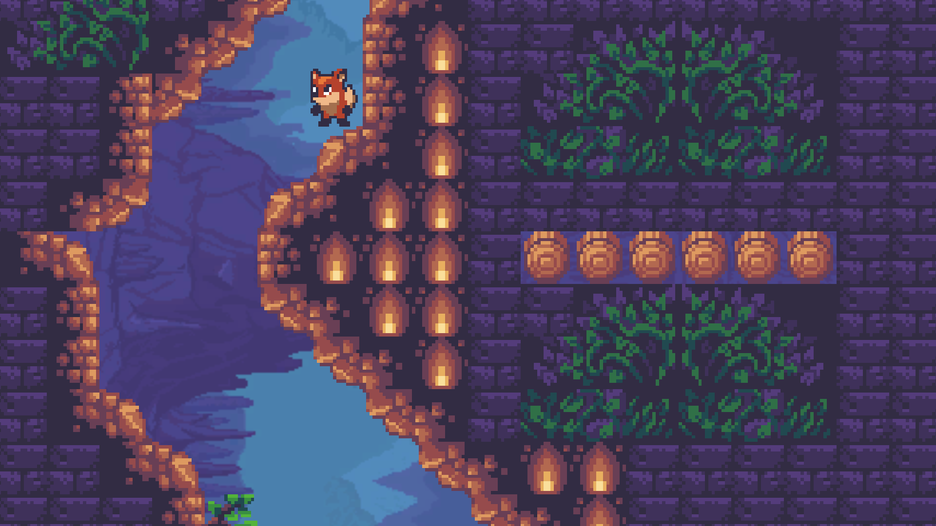

Creating emotions looking at trapped fire lanterns and fauna will make then player wonder.

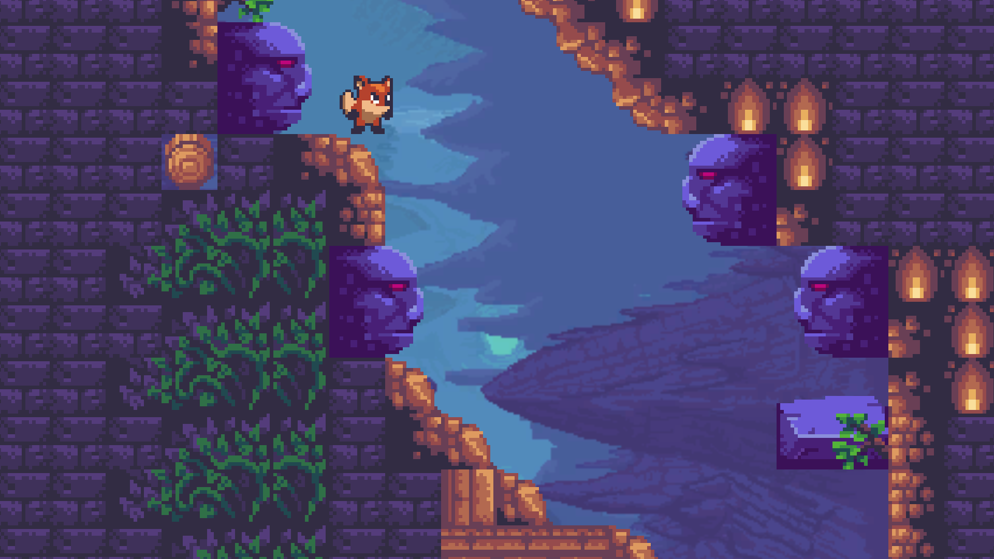

Spooky heads.

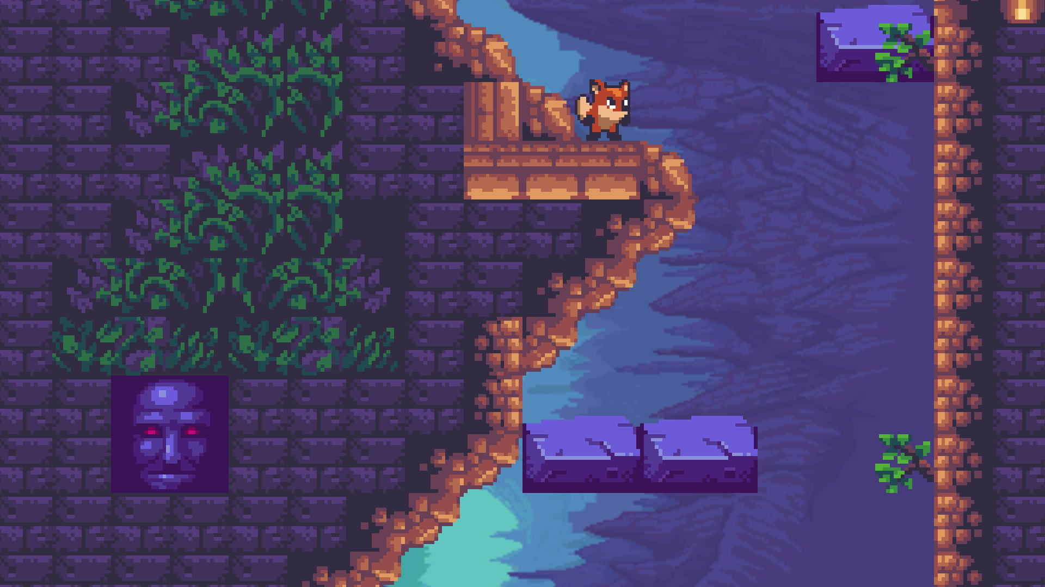

Feeling of being watched to create emotions similar to danger.

## 14.3 Audio

|  |  |  |  |
| --- | --- | --- | --- |
| **Name** | **Category** | **Description** | **Source** |
| game.mp3 | Background Music | Plays During game level. | <https://www.ashamaluevmusic.com/ambient-music> |
| Intro.mp3 | Background Music | Plays During game story intro. | <https://www.youtube.com/watch?v=Rm-2gKAvnZY> |

# 15 Procedurally Generated Content

None. All environments and objects are pre-generated.

## 15.6 Minimum Viable Product (MVP)

* One Player character to choose from (Boy)
* Built for the PC platform

# 16 Wish List

* Add Reward System.
* Add More difficult Obstacles.
* Add a way to climb back after achieving the objective.